

WF6000 SDK
User Guide

Version 1.0
2019. 1. 30

Copyright © 1996-2013 I&C Technology Co., Ltd.. All rights reserved. No part of this publication may be reproduced, transmitted, transcribed, or translated into any language or computer format, in any form or by any means without prior written permission of:
I&C Technology Co., Ltd.,
I&C Building, Pangyo-ro255 24, Bundang-gu, Seongnam-si, Gyeonggi-do, 463-400, South KoreaI&C Technology Co., Ltd. reserves the right to make changes to the product(s) or specifications to improve performance, reliability, or manufacturability. Information furnished is believed to be accurate and reliable, but I&C Technology Co., Ltd. shall not be responsible for any errors that may appear in this document. I&C Technology Co., Ltd. makes no commitment to update or keep current the information contained in this document.
However, no responsibility is assumed for its use; or any infringement of patents or other rights of third parties, which may result from its use. No liability is assumed as a result of their use or application. No rights under any patent accompany the sale of any such product(s) or information.
I&C Technology Co., Ltd. products are not designed or intended for use in Life Support Systems. A Life Support System is a product or system intended to support or sustain life, which if it fails, can be reasonably expected to result in significant personal injury or death. If Buyer or any of its direct or indirect customers applies any product purchased or licensed from I&C Technology Co., Ltd. to any such unauthorized use, Buyer shall indemnify and hold I&C Technology Co., Ltd., its affiliates and their respective suppliers, harmless against all claims, costs, damages and expenses arising directly or indirectly, out of any such unintended or unauthorized use, even if such claims alleges that I&C Technology Co., Ltd. or any other person or entity was negligent in designing or manufacturing the product.
Specifications are subject to change without notice.

Table of Contents

1 Introduction 5
1.1 Scope 5
1.2 References 5
2 WF6000 SDK Development Environment Composition 6
2.1 Firmware Build Environment (Linux OS) 6
2.1.1 Shared Folder Set 6
2.1.2 VirtualBox Network Setting and Samba Installation 7
2.1.3 Xtensa toolchain Setting 8
2.2 WF6000 SDK Build 8
2.3 Firmware Download 10
2.4 MAC Address Read/Write 13
2.5 Download with SF_Loader of Mask Rom 15
3 WF6000 SDK Examples 17
3.1 gpio_led_blink 17
3.1.1 GPIO Input and Output Setting 17
3.1.2 GPIO Reset and Task Create 17
3.1.3 Switch Input Control 18
3.1.4 LED On/Off Control 19
3.2 gpio_ext_intr 20
3.2.1 Set to GPIO Interrupt Port 20
3.2.2 Interrupt Reset and Task Create 20
3.2.3 External Interrupt Process 21
3.3 ping 23
3.3.1 AP and Network Setting 23
3.3.2 Event Handler 24
3.4 Scan 26
3.4.1 AP Scan 26
3.4.2 Event Handler 27
3.5 wlan_operation 27
3.5.1 Operation Mode Select 27
3.5.2 AP Mode Start 28
3.5.3 Station Mode Start 29
3.5.4 Operation Stop 29
3.5.5 Event Handler 30
3.6 sw_timer 31
3.6.1 GPIO Output Set for Soft Timer Test 31
3.6.2 Soft Timer Reset 31
3.6.3 Soft Timer Start 32
3.6.4 Event Handler 33
3.7 wdt 33
3.7.1 Watchdog Timer Set and Test 33

Introduction

Scope
This document explains examples for development efficiency using WF6000 SDK, Linux development environment and Firmware Download.

References
WF5000_WF6000_Alphabeam_SDK_APIs.pdf

WF6000 SDK Development Environment Composition

Firmware Build Environment (Linux OS)

The following information is based on Ubuntu 14.04.
After installing Ubuntu on VirtualBox, set shared folders or install Samba for the convenience of Windows and moving files, Firmware Build and Download.

Shared Folder Set

- Select Shared Folder

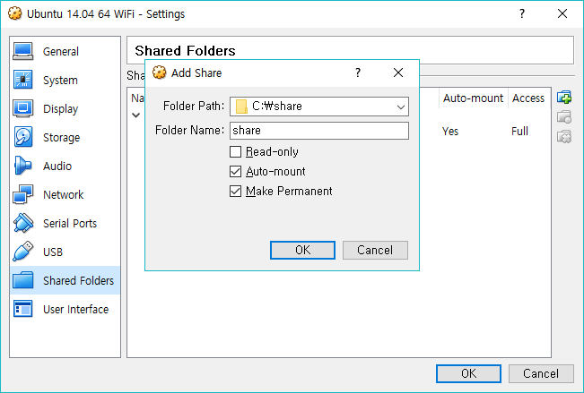

- Reboot after setting Group to access Shared Folder. [User account: inc]
$ cd /media
$ ls
sf_share
$ sudo usermod –aG vboxsf inc
$ sudo shutdown –r now

- Go to Shared Folder after Rebooting.
$ cd /media/sf_share
$ ls
wf6000_sdk.tar.gz

VirtualBox Network Setting and Samba Installation

- Set Ubuntu Network

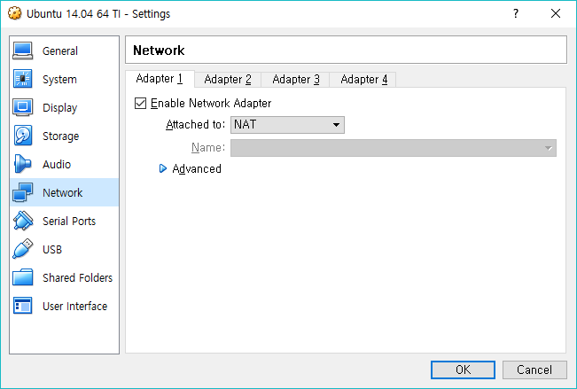

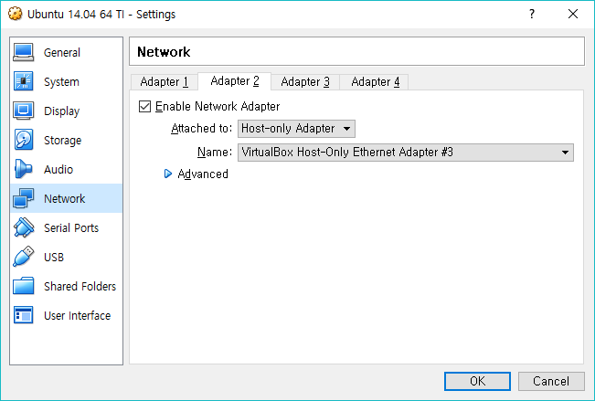

- Install and Set Samba
$ sudo apt-get install samba samba-common
$ sudo apt-get install system-config-samba cifs-utils
$ cd ~
$ mkdir wf6000
$ sudo vi /etc/samba/smb.conf

[wf6000]
comment = ubuntu samba
read only = no
writable = yes
path = /home/inc/wf6000
guest ok = no
browseable = yes
public = yes
writable = yes

$ sudo smbpasswd -a wf6000
…
$ sudo /etc/init.d/samba restart

Xtensa toolchain Setting

- Change Permission of xtensa-IncCacheV7-elf.tar.gz.
$ cd /home/inc
$ sudo tar xfz xtensa-IncCacheV7-elf.tar.gz
$ sudo chmod –R +x xtensa-IncCacheV7-elf

- Append the following Path to ~./bashrc on the last line
$ cd ~
$ vi .bashrc
…
export PATH=${PATH}:~/xtensa-IncCacheV7-elf/bin
$ source .bashrc

WF6000 SDK Build

- Copy wf6000_sdk.tar.gz to the working location (samba directory), decompress it, and change Permission
$ cp wf6000_sdk.tar.gz /home/inc/wf6000
$ sudo tar xfz wf6000_sdk.tar.gz
$ chmod –R +x wf6000_sdk

- Go to examples of wf6000_sdk and proceed with firmware Build. If Build is normal, you can check the below Massage without error.
$ cd ./wf6000_sdk/examples
$ ls
at_command ping sample sniffer wdt
gpio_ext_intr pwm scan socket wlan_operation
gpio_led_blink rf_tuning security_engine sw_timer
$ cd ping
$ ls
build.sh inc src
$ ./build.sh
======================================= CONFIG
CURR_DIR: /home/kdk/kdk_sb/wf6000/release_sdk/wf6000_sdk/examples/ping
USER_DIR: ping
======================================= CLEAN
rm: cannot remove ‘*.bin’: No such file or directory
sf_loader/Makefile:139: bin_info_cfg: No such file or directory
make: *** No rule to make target `bin_info_cfg'. Stop.
======================================= COMPILE
…
…
…
DRAM code offset : 0x28000
SF code MAX size : 1024 KB
Enable a IRAM OVERLAP in SF_Loader, change a MAX_TEXT_SIZE from 118783 to 131072 bytes
DRAM : starting from 0x3ffa8000 to 0x3ffbffff, length(0x18000)
(rodata+data: 96KB/160KB) + (bss: 144KB) + (mac_buff: 160KB) = 400KB
IRAM : starting from 0x40000000 to 0x40013fff, length(0x14000)
SROM_CODE : srom_text_size : 0x000909f0 hdr->srom_size : 0x244
SROM_RO_DATA : srom_ro_data_size : 0x00000000 hdr->srom_size : 0x244

FW INFO : AB5 version(0x1A651140:V4416) for SF_LOADER (align 0x1000)
DRAM 0x3ffa8000 (0096KB:0160KB), CRC16(0xc6c5)
IRAM 0x40000000 (0080KB:0128KB), CRC16(0xd155)
SROM 0x5004c000 (0580KB:1024KB), CRC16(0xb2ba)
Total sizes : 888832 (0xd9000) Bytes.
4+0 records in
4+0 records out
16384 bytes (16 kB) copied, 0.00353527 s, 4.6 MB/s
217+0 records in
217+0 records out
888832 bytes (889 kB) copied, 0.000856974 s, 1.0 GB/s
======================================= END
$

Firmware Download

- Connect the UART0 of WF6000 SFP2501 EVB to PC and run Update Tool.
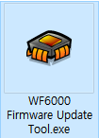

- When Update Tool is executed, check Uart Port of the connected PC.
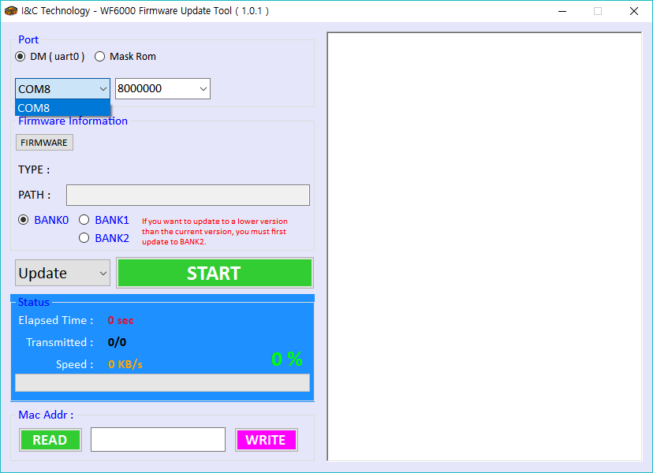

- Check UART0 Baudrate of the WF6000 SFP2501 EVB in operation and select it.
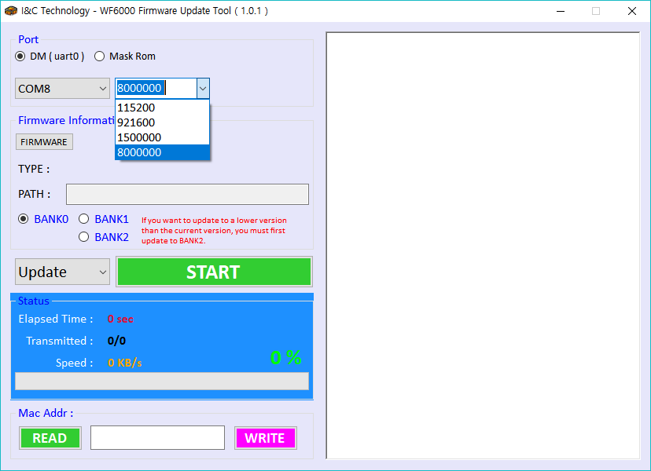

- Click FIRMWARE to select the bin file to download
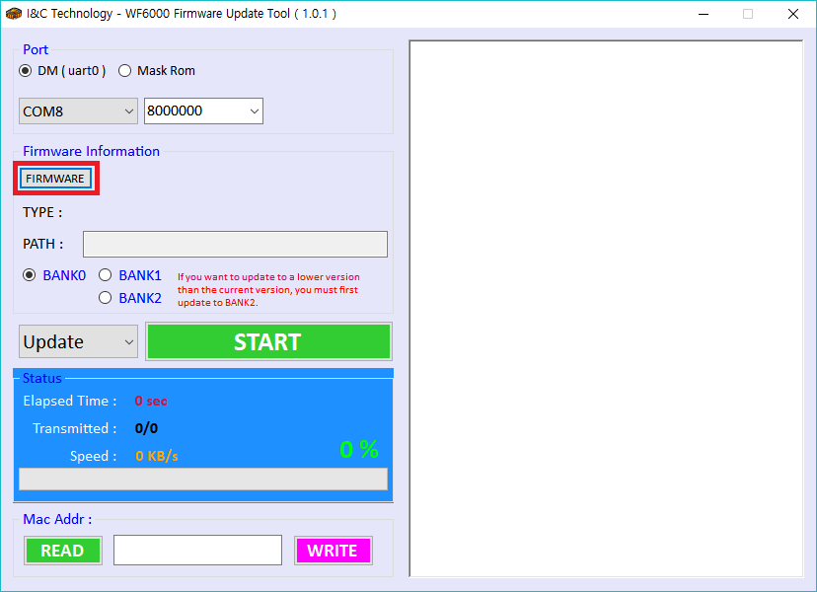

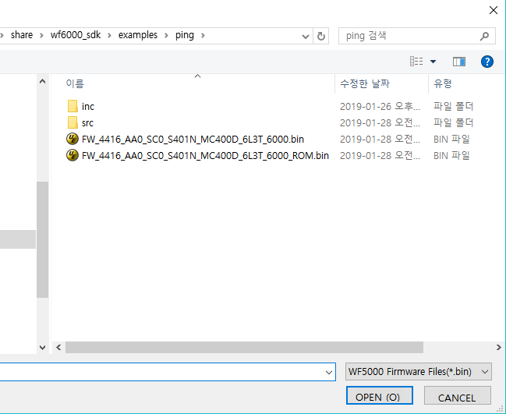

- FW_xxxx_AA0_SC0_S401N_MC400D_6L3T_6000.bin (Firmware)
Select BANK1 or BANK2 to download Firmware
- FW_xxxx_AA0_SC0_S401N_MC400D_6L3T_6000_ROM.bin (SF_Loader + Firmware)
If you select BANK0 to download, SF_Loader is downloaded to BANK0 and Firmware is downloaded to Bank1.

- Select file and press START to download Firmware.
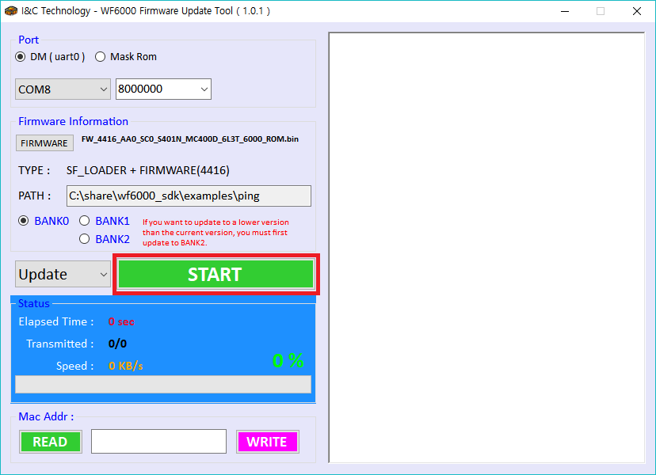

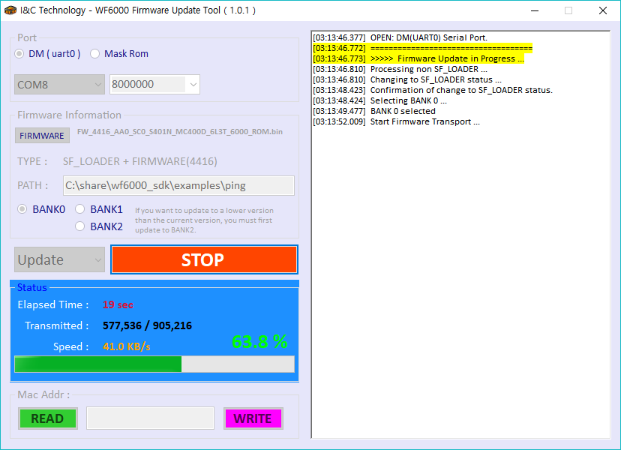

- When Firmware is normally downloaded, Firmware transfer successful Massage is displayed on the right side. After this, COM Port is automatically closed.
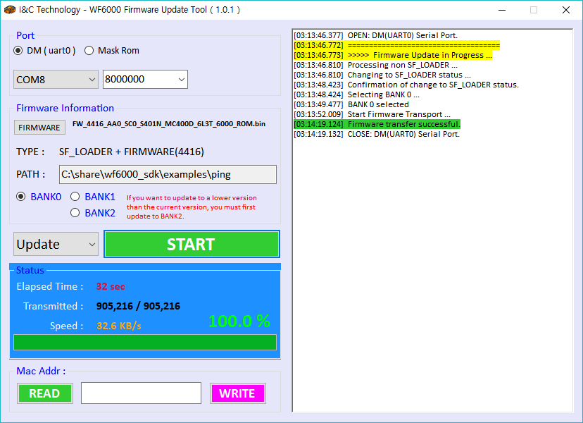

MAC Address Read/Write
- Click Read to read MAC Address.
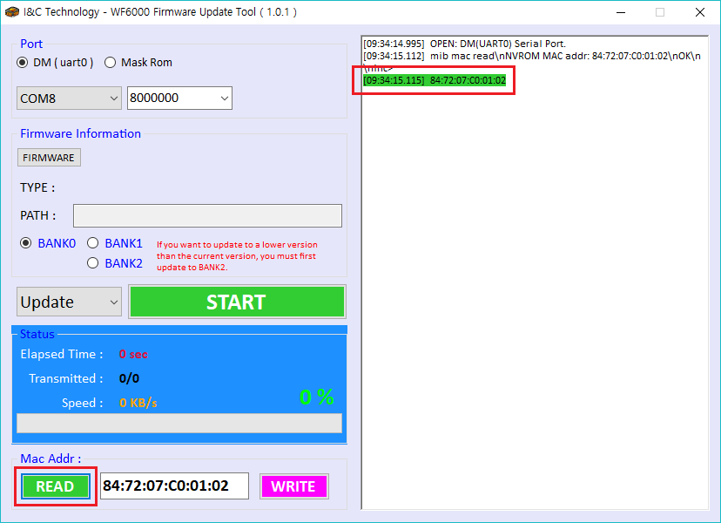

- If you change the current MAC Address, click WRITE to change MAC Address after editing MAC Address at the bottom
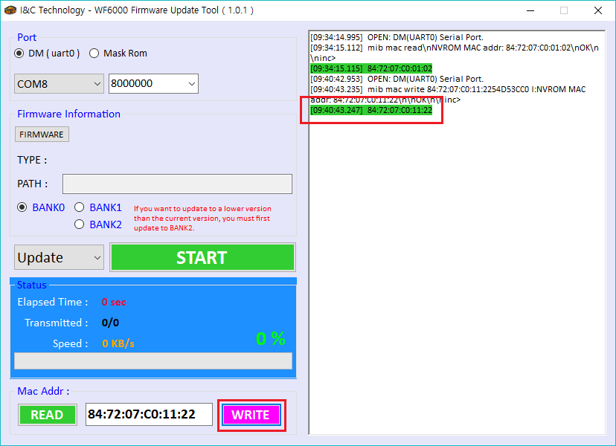

Download with SF_Loader of Mask Rom

If WF6000 SFP2501 EVB is not operated and Firmware is not downloaded to DM, select MASK ROM to download Firmware

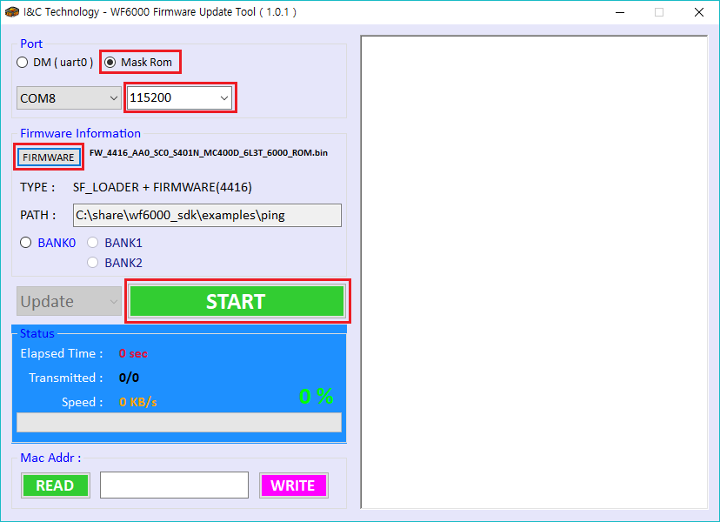

- Select Mask Rom
- Baudrate 115200
- Click Firmware
- Select file (FW_xxxx_AA0_SC0_S401N_MC400D_6L3T_6000_ROM.bin)
- After clicking START, if the following dialog box is displayed, power off WF6000 SFP2501 EVB and then on again, Firmware proceeds when Rebooting is detected.

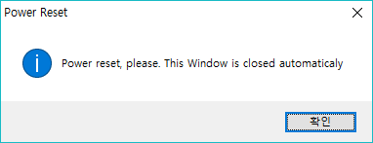

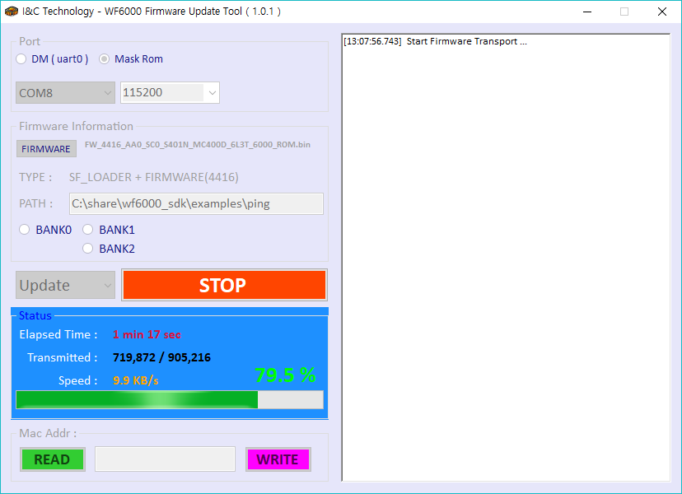

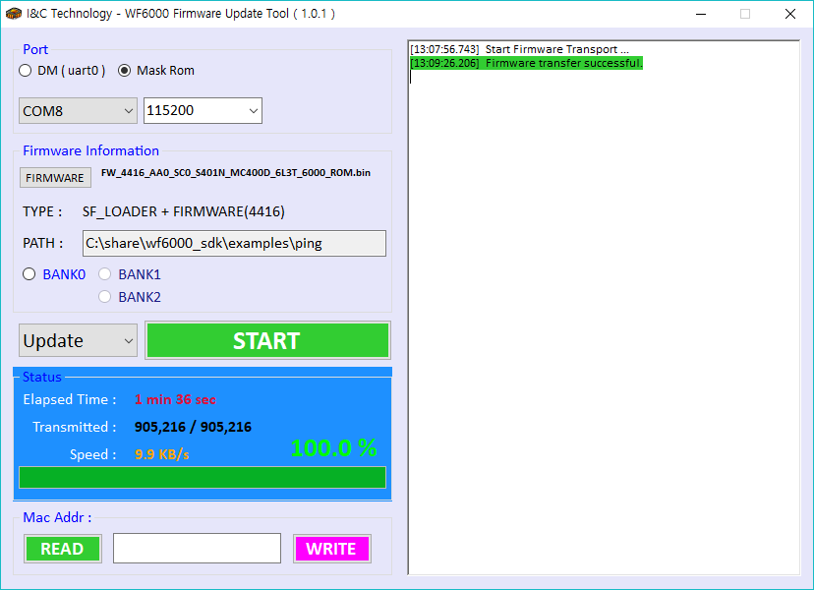

- When Firmware transfer successful Massage is displayed, reset to restart WF6000 SFP2501 EVB.

WF6000 SDK Examples

gpio_led_blink
It’s an example of GPIO input and output.
GPIO_10 to which Switch is connected is set as input. GPIO_10 is set to ‘1’ and ‘0’ when Switch is pressed
GPIO_11 is set as output and if outputting ‘1’, LED is off, if outputting ‘0’, LED is on.
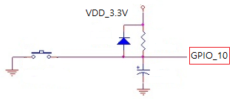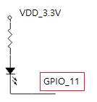

GPIO Input and Output Setting
void gpio_output_init(UINT8 gpio)
{
ict_api_sys_gpio_set_pad(gpio, 1); /* 1: GPIO Enable, 0: GPIO Disable */
ict_api_sys_gpio_set_direction(gpio, 1); /* 1: Output Mode, 0: Input Mode */
ict_api_sys_gpio_set_output(gpio, 1);
}

void gpio_input_init(UINT8 gpio)
{
ict_api_sys_gpio_set_pad(gpio, 1); /* 1: GPIO Enable, 0: GPIO Disable */
ict_api_sys_gpio_set_direction(gpio, 0); /* 1: Output Mode, 0: Input Mode */
}

GPIO Reset and Task Create

static void gpio_task(void *arg)
{
…
/* Control LED On/Off according to Switch input. */
while(1)
{
ict_api_os_time_delay(1); // 10ms
gpio_button_proc();
gpio_led_proc();
}
}

void user_start()
{
…

gpio_output_init(led_port); /* GPIO_11 */
gpio_input_init(gpio_btn_port); /* GPIO_10 */

if (p_gpio_task == ICT_NULL)
{
…
/*Create Task to perform functions on GPIO input and output */
result = ict_api_tn_task_create(p_gpio_task,
"gpio",
gpio_task,
NULL,
&gpio_task_stack[GPIO_TASK_STACK_SIZE-1],
GPIO_TASK_STACK_SIZE,
GPIO_TASK_PRI);
}

return;
}

Switch Input Control
It is a State Machine for controlling LED state by determining the state according to the increased value of btn_bnc_cnt by increasing btn_bnc_cnt while the input value is '0' after Switch is connected.
State according to the value in each btn_bnc_cnt is as follows.
- BTN_FSM_IDLE : While the input value at the initial state, curstate is ‘0’, if the value of btn_bnc_cnt is incremented by 1 every 10ms and becomes 100 or more, State Machine is switched to BTN_FSM_CHECK_LONG_PRESS
If it is smaller than 100, it is switched to the BTN_FSM_CHECK_SHORT_PRESS.
- BTN_FSM_CHECK_LONG_PRESS : LED becomes Off.
- BTN_FSM_CHECK_SHORT_PRESS : LED becomes Blink every 500ms.

void gpio_button_proc (void)
{
UINT32 curstate = 0;
UINT16 out_val = 0; // Switch Debouncing

curstate = ict_api_sys_gpio_get_input(gpio_btn_port);

switch(gpio_fsm)
{
case BTN_FSM_IDLE:
if(curstate == 0)
{
btn_bnc_cnt++;

if (btn_bnc_cnt >= long_key_time_ms)
{
gpio_fsm = BTN_FSM_CHECK_LONG_PRESS;
}
}
else
{
if(btn_bnc_cnt)
{
gpio_fsm = BTN_FSM_CHECK_SHORT_PRESS;
}

btn_bnc_cnt = 0;
}
break;

case BTN_FSM_CHECK_LONG_PRESS:
gpio_fsm = BTN_FSM_WAIT_UNPRESS;
gpio_state = BTN_LONG;
printf("T: Button State : LONG\n");
break;

case BTN_FSM_CHECK_SHORT_PRESS:
gpio_fsm = BTN_FSM_WAIT_UNPRESS;
gpio_state = BTN_SHORT;
printf("T: Button State : SHORT\n");
break;

case BTN_FSM_WAIT_UNPRESS:
if (curstate == 1)
{
gpio_fsm = BTN_FSM_IDLE;
btn_bnc_cnt = 0;
}
break;

default:
break;
}
}

LED On/Off Control
Control LED On/Off according to the state information of Switch.
LED control according to the state of Switch is as follows.
- LED_IDLE : LED at the initial state is off
- LED_BLINK : LED blinks every 500ms.
- LED_OFF : LED becomes Off.

void gpio_led_proc(void)
{
UINT16 out_val = 0;

switch(gpio_led_state)
{
case LED_IDLE:
break;

case LED_BLINK:
if(led_blink_interval == 0)
{
out_val = (UINT16)ict_api_sys_gpio_get_output(led_port);
ict_api_sys_gpio_set_output(led_port, ((~out_val) & 0x0001));
led_blink_interval = 50;
}
else
{
led_blink_interval--;
}
break;

case LED_OFF:
ict_api_sys_gpio_set_output(led_port, 1);
printf("T: LED Off\n");
gpio_led_state = LED_IDLE;
break;

default:
break;
}
}

gpio_ext_intr
GPIO is an example used as External Interrupt Port.
Set GPIO_10 connected to Switch to External Interrupt Port.
Each time an interrupt is generated by pressing Switch, the LED connected to GPIO_11 changes its On / Off.

Set to GPIO Interrupt Port
void gpio_ext_intr_init(UINT8 gpio)
{
ict_api_sys_gpio_set_pad(gpio, 1); /* 1: GPIO Enable, 0: GPIO Disable */
ict_api_sys_gpio_set_direction(gpio, 0); /* 1: Output Mode, 0: Input Mode */
ict_api_sys_gpio_set_sensitivity(gpio, 1); /* 1: Level Interrupt, 0: Edge Interrupt */
ict_api_sys_gpio_set_ipolarity(gpio, 0); /* 1: High Polarity, 0: Low Polarity */
}

Interrupt Reset and Task Create
Reset GPIO to External Interrupt Port and register gpio_ext_intr_handler Callback function.
static void gpio_task(void *arg)
{
…

/* Control LED according to the occurrence of Interrupt every10ms */
while(1)
{
ict_api_os_time_delay(1); // 10ms
gpio_intr_btn_proc();
}
}

void user_start()
{
…

gpio_output_init(led_port);

/* Interrupt Port Initialization */
gpio_ext_intr_init(ext_intr_port);
/* Interrupt Flags All Clear */
ict_api_sys_gpio_set_istatus(0xFFFFFFFF);
/* Registering an Interrupt Handler */
ict_api_sys_gpio_enable(ext_intr_port, gpio_ext_intr_handler);

/* create task */
if (p_gpio_task == ICT_NULL)
{
…
result = ict_api_tn_task_create(p_gpio_task,
"gpio",
gpio_task,
NULL,
&gpio_task_stack[GPIO_TASK_STACK_SIZE-1],
GPIO_TASK_STACK_SIZE,
GPIO_TASK_PRI);
}

return;
}

External Interrupt Process
Whenever Interrupt occurs, Handler is called and ext_intr_flag is set to '1'. pirntf function is not used within Handler function. Log is not output even if it is used.
When Interrupt is created by Switch, Bounce occurs. The user tries to create only one Interrupt but several Interrupts may occur unintentionally due to mechanical contact. Debounce processing is required to prevent unintentional interrupts.
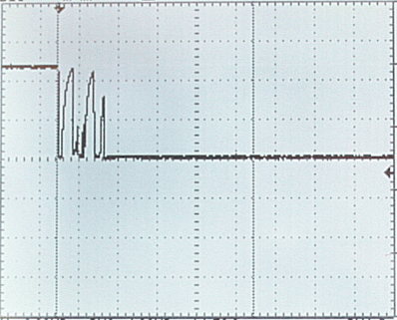

The following is the state information of State Machine for Interrupt processing
- INTR_FSM_IDLE : It is the state before Interrupt. When Interrupt occurs, it is switched to INTR_FSM_DEBOUNCE .
- INTR_FSM_DEBOUNCE : If you press Switch, Bounce may occur for tens of ms. Ensure that Bounce created for 100 ms is not recognized as another interrupt. It’s switched to INTR_FSM_LED_CTRL after 100ms.
- INTR_FSM_LED_CTRL : If LED is On, it’s controlled to OFF, if LED is Off, it’s controlled to On. Then, it’s switched to INTR_FSM_END
- INTR_FSM_END : Close Interrupt processing created by clearing ext_intr_flag as ‘0’. After this, it’s switched to INTR_FSM_IDLE, an Interrupt wait state.

void gpio_ext_intr_handler(void)
{
/* Can not use printf function */
ext_intr_flag = 1;
}

void gpio_intr_btn_proc (void)
{
UINT32 curstate = 0;
UINT16 out_val = 0;

curstate = ict_api_sys_gpio_get_input(ext_intr_port);

switch(intr_fsm)
{
case INTR_FSM_IDLE:
if((ext_intr_flag == 1) && (curstate == 0))
{
printf("T: INTR_FSM_IDLE : Interrupt has happend!\n");
intr_fsm = INTR_FSM_DEBOUNCE;
btn_bnc_cnt = 10; // about 100ms
}
else
{
ext_intr_flag = 0;
}
break;

case INTR_FSM_DEBOUNCE:
if(btn_bnc_cnt)
{
btn_bnc_cnt--;
}
else
{
printf("T: INTR_FSM_DEBOUNCE : Debounce finish!\n");
intr_fsm = INTR_FSM_LED_CTRL;
}
break;

case INTR_FSM_LED_CTRL:
out_val = (UINT16)ict_api_sys_gpio_get_output(led_port);
ict_api_sys_gpio_set_output(led_port, ((~out_val) & 0x0001));

intr_fsm = INTR_FSM_END;
break;

case INTR_FSM_END:
ext_intr_flag = 0;
intr_fsm = INTR_FSM_IDLE;
printf("T: INTR_FSM_END\n");
break;

default:
break;
}
}

ping
It’s an example of executing Ping Test after connecting with AP.

AP and Network Setting
You can set Station's IP to access AP to Static or DHCP.
Register ping_event_handler Callback function to process Event created during connecting with AP and ping operation.
Create ping_operation_task for Ping Test with the connected AP.

void user_config(void)
{
UINT8 ssid[32] = "test_ap"; /* SSID */
UINT8 password[32] = ""; /* or "12345678" */
UINT16 dhcp_en = ICT_TRUE; /* DHCP */

UINT32 cnt;

ICT_MEMSET(&ping_local_ip_params, 0x00, sizeof(ICT_ST_IP_CONFIG_T));

ping_local_ip_params.dhcp_mode = dhcp_en;
if(dhcp_en == ICT_FALSE)
{
/* Example Static IP */
IP4_ADDR_(ping_local_ip_params.ipaddr, 10, 0, 0, 10);
IP4_ADDR_(ping_local_ip_params.subnet, 255, 255, 255, 0);
IP4_ADDR_(ping_local_ip_params.gateway, 10, 0, 0, 1);
IP4_ADDR_(ping_local_ip_params.dns, 164, 124, 101, 2);
}

ICT_MEMSET(&ping_req_join, 0x00, sizeof(ICT_ST_JOIN_REQ_T));
ping_req_join.ssid_len = ICT_STRLEN(ssid);
ICT_STRCPY(ping_req_join.ssid, ssid);
ping_req_join.key_len = ICT_STRLEN(password);
ICT_STRCPY(ping_req_join.key, password);
}

void user_start(void)
{
…
user_config();
ict_cm_wlan_event_callback_register((void *)ping_event_handler);
ping_connect_to_ap(&ping_local_ip_params, &ping_req_join);

/* create task */
if (p_ping_task == ICT_NULL)
{
…
result = ict_api_tn_task_create(p_ping_task,
"ping",
ping_operation_task,
NULL,
&ping_task_stack[PING_TASK_STACK_SIZE-1],
PING_TASK_STACK_SIZE,
PING_TASK_PRI);
}

…

return;
}

Event Handler
If Event occurs during AP connection and Ping Test, ping_event_handler function registered on Callback is called and the created event is as follows.
- ICT_HIF_CMD_ST_JOIN_IND: It occurs after connection attempt with AP. If the connection is successful, Join State is ICT_TRUE, if unsuccessful, it’s ICT_FALSE.
- ICT_HIF_CMD_ST_DISCONNECTED_IND : It occurs when connection is lost after connection.
- ICT_HIF_CMD_ST_NETWORK_INFO_IND : It occurs when Network information is received after successful connection. Station performs Ping Test from Network information to Gateway

After executing Ping Test in ping_operation_task, the following Event occurs and you can check the result of Ping.
- ICT_HIF_CMD_ST_PING_REPLY_IND : It occurs at the time of ping transmission and response during Ping Test. You can check the result of Ping Test.
- ICT_HIF_CMD_ST_PING_RESULT_IND : Ping Test occurs at the end. You can check the result of Ping Test.

void ping_event_handler(T_MAC_EVENT *p_mac_event)
{
switch(p_mac_event->code)
{
case ICT_HIF_CMD_ST_JOIN_IND:
if(ict_api_join_state(p_mac_event->buf) == ICT_TRUE)
{
printf("I: ASSOCIATED!\n");
assoc_flag = ICT_TRUE;
}
else
{
printf("W: DISCONNECT!\n");
}
break;

case ICT_HIF_CMD_ST_DISCONNECTED_IND:
printf("E: DISASSOCIATED!!\n");
assoc_flag = ICT_FALSE;
break;

case ICT_HIF_CMD_ST_NETWORK_INFO_IND:
printf("I: NETWORK_INFO_IND!!\n");
{
ICT_ST_NETWORK_INFO_IND_T *network_ind;
network_ind = (ICT_ST_NETWORK_INFO_IND_T *)p_mac_event->buf;

ICT_MEMCPY(&ping_net_info, network_ind, sizeof(ICT_ST_NETWORK_INFO_IND_T));

printf("IP "IPSTR"\n", IP2STR(network_ind->ipaddr));
printf("SUBNET "IPSTR"\n", IP2STR(network_ind->subnet));
printf("GATEWAY "IPSTR"\n", IP2STR(network_ind->gateway));
printf("DNS "IPSTR"\n", IP2STR(network_ind->dns));
}
ping_start = ICT_TRUE;
break;
case ICT_HIF_CMD_ST_PING_REPLY_IND:
{
ICT_ST_PING_DATA_INFO_T *pin_reply_info;
pin_reply_info = (ICT_ST_PING_DATA_INFO_T *)p_mac_event->buf;

printf("PING_REPLY: "IPSTR" data_len = %d(bytes) : time = %d(ms)\n", IP2STR(pin_reply_info->ipaddr),
pin_reply_info->ping_data_len,
pin_reply_info->ping_time);
}
break;

case ICT_HIF_CMD_ST_PING_RESULT_IND:
{
ICT_ST_PING_DATA_INFO_T *pin_reply_info;
pin_reply_info = (ICT_ST_PING_DATA_INFO_T *)p_mac_event->buf;

printf("PING_RESULT: "IPSTR" repeat_num = %d : result = %d\n",
IP2STR(pin_reply_info->ipaddr),
pin_reply_info->repeat_num,
pin_reply_info->ping_result);
}
break;
}
}

static void ping_operation_task(void *arg)
{
static UINT32 repeat_cnt = 4;
…
while(1)
{
if((assoc_flag == ICT_TRUE) && (ping_start == ICT_TRUE))
{
if(first_start == ICT_TRUE)
{
ict_api_ping_test_handler(ping_net_info.gateway, 1024, repeat_cnt);
first_start = ICT_FALSE;
}

if(num == ((repeat_cnt * 10) + 10))
{
ict_api_ping_test_handler(ping_net_info.gateway, 1024, repeat_cnt);
num = 0;
}
}

ict_api_tn_task_sleep(10); // 100msec sleep

num++;
}

}

Scan
It’s an example of checking AP information by scanning the surrounding AP

AP Scan
After scanning all channels in the 2.4GHz band and the 5GHz band, you can check Channel, SSID, BSSID, and RSSI of each AP.You can scan only a specific channel using a known SSID.
Before scanning, reset ap_list and register Handler called from Scan Event created in the scan operation.
Start Scan after updating the channel List or SSID to be scanned to Parameter of wlan_start_scan.
void user_start(void)
{
ICT_ST_SCAN_REQ_T params;
UINT16 channel_list[] = {
1, 2, 3, 4, 5, 6, 7, 8, 9, 10, 11, 12, 13,
36, 40, 44, 48,
52, 56, 60, 64,
100, 104, 108, 112, 116,
120, 124, 128,
149, 153, 157, 161, 165,
0
};

…

printf("--- init scan list.\n");
wlan_init_scan_ap_list();

printf("--- register scan callback function.\n");
ict_cm_wlan_scan_event_callback_register(wlan_scan_event_handler);

ict_api_memset(&params, 0x00, sizeof(ICT_ST_SCAN_REQ_T));
params.channel = channel_list;

/* all scan */
if (1)
{
printf("--- start to scan\n");
wlan_start_scan(&params);
}

/* specific scan */
if (0)
{
ict_api_memset(params.ssid, 0x00, 32);
ict_api_strcpy(params.ssid, "KNOWN_SSID");
params.ssid_len = ict_api_strlen((char*)params.ssid);

printf("--- start to scan the specific SSID (%s)\n", params.ssid);
wlan_start_scan(&params);
}

return;
}

Event Handler
If Event occurs in the Scan operation, wlan_scan_event_handler function registered on Callback is called and the created Event is as follows.
- ICT_HIF_CMD_ST_SCAN_IND : If there is information about AP at each Channel scan, it ‘s transmitted with Handler Parameter. AP information is stored in wlan_insert_scan_ap_list.
- ICT_HIF_CMD_ST_SCAN_RST_IND : It occurs when Scan ends. After Scan is completed, the stored AP information can be checked by wlan_print_scan_ap_list.
void wlan_scan_event_handler(T_MAC_EVENT *p_mac_event)
{
switch(p_mac_event->code)
{
case ICT_HIF_CMD_ST_SCAN_IND:
printf("---- ICT_HIF_CMD_ST_SCAN_IND.\n");
if (p_mac_event->buf)
{
ICT_ST_SCAN_IND_T *p_scan_ind = (ICT_ST_SCAN_IND_T *)p_mac_event->buf;

wlan_insert_scan_ap_list(p_scan_ind);
}
break;

case ICT_HIF_CMD_ST_SCAN_RST_IND:
printf("---- ICT_HIF_CMD_ST_SCAN_RST_IND\n");
wlan_print_scan_ap_list();
break;

default:
printf("E:[%s] unknown event. (%X)\n", __func__, p_mac_event->code);
break;
}
}

wlan_operation
wlan_operation is an example of executing AP Mode and Station Mode.

Operation Mode Select
It operates with AP or Station according to the setting value of operation_mode
You can check AP and Station Mode connection state and Network information depending on Event occurred by registering wlan_operation_event_handler Callback function.

…
static WLAN_MODE opration_mode = WLAN_AP_MODE; // or WLAN_STATION_MODE
…

void user_start(void)
{
…

ict_cm_wlan_event_callback_register((void *)wlan_operation_event_handler);

if(opration_mode == WLAN_AP_MODE)
{
wlan_operation_mode_ap_start();
}
else
{
wlan_operation_mode_station_start();
}

/* create task */
if (p_wlan_task == ICT_NULL)
{
…

result = ict_api_tn_task_create(p_wlan_task,
"wlan",
wlan_operation_task,
NULL,
&wlan_task_stack[WLAN_TASK_STACK_SIZE-1],
WLAN_TASK_STACK_SIZE, WLAN_TASK_PRI);
}

…

return;
}

AP Mode Start
Set channel, security method, code in the format of ap_connect[] = “…” String. In case of the set Network information, it’s saved with ict_api_nv_set_apnet function. AP Mode is started by transmitting ap_connect information to ict_api_apconn_handler function with Parameter and executing it.

void wlan_operation_mode_ap_start()
{
…
uint8_t ap_connect[128];

/* if needed, set IP config */
if (1)
{
uint8_t ip[4], subnet[4], gateway[4], lease_ip_min, lease_ip_max;

IP4_ADDR_(ip, 192, 168, 43, 1);
IP4_ADDR_(subnet, 255, 255, 255, 0);
IP4_ADDR_(gateway, 192, 168, 43, 1);
lease_ip_min = 20;
lease_ip_max = 200;

ict_api_nv_set_apnet(ip, subnet, gateway, &lease_ip_min, &lease_ip_max);
}

wlan_get_mac_address(mac_addr);

ICT_MEMSET(ap_connect, 0x00, 128);

/* [ssid] [ch/freq] {wep/wpa/wpa2} {tkip/ccmp} {tkip/ccmp} {passphrase} */
ap_connect[] = " TEST_AP 149 wpa2 ccmp ccmp 12345678"

ICT_SPRINTF(ap_connect, "TEST_AP 149 wpa2 ccmp ccmp 12345678");

result = ict_api_apconn_handler(ICT_FALSE, ap_connect, (UINT32)ICT_STRLEN((char*)ap_connect));
…
}

Station Mode Start
For Station Mode, Network is set to Static or DHCP.
Start Station Mode by executing ict_api_join_handler function.

void wlan_operation_mode_station_start()
{
UINT8 ssid[32] = "tset_ap"; /* SSID */
UINT8 password[32] = ""; /* or "12345678" */
UINT16 dhcp_en = ICT_TRUE; /* DHCP */
ICT_ST_IP_CONFIG_T params;
ICT_ST_JOIN_REQ_T join_req;
INT32 result;
UINT32 cnt;

ICT_MEMSET(&params, 0x00, sizeof(ICT_ST_IP_CONFIG_T));

params.dhcp_mode = dhcp_en;
if(dhcp_en == ICT_FALSE)
{
/* Example Static IP */
IP4_ADDR_(params.ipaddr, 10, 0, 0, 10);
IP4_ADDR_(params.subnet, 255, 255, 255, 0);
IP4_ADDR_(params.gateway, 10, 0, 0, 1);
IP4_ADDR_(params.dns, 164, 124, 101, 2);
}

ICT_MEMSET(&join_req, 0x00, sizeof(ICT_ST_JOIN_REQ_T));
join_req.ssid_len = ICT_STRLEN(ssid);
ICT_STRCPY(join_req.ssid, ssid);
join_req.key_len = ICT_STRLEN(password);
ICT_STRCPY(join_req.key, password);

if (join_req.ssid_len) printf("ssid: %s\n", join_req.ssid);
if (join_req.key_len) printf("pwd: %s\n", join_req.key);

result = ict_api_join_handler(&join_req);
}

Operation Stop
You can stop the operating mode by calling the following function

void wlan_operation_mode_ap_stop()
{
printf("[%s] called.\n", __func__);
ict_api_apstop_handler();
}

void wlan_operation_mode_station_stop()
{
printf("[%s] called.\n", __func__);
ict_api_disconnect_handler(NULL);
}

Event Handler
If it operates in AP or Station Mode, when Event occurs, it is called to wlan_operation_event_handler registered on Callback function, and you can check the current connection state or network information. Events that occur are as follows.
- ICT_HIF_CMD_ST_AP_START_IND : Occurs after Start in AP Mode
- ICT_HIF_CMD_ST_AP_STOP_IND : Occurs when AP Mode is stopped, if calling wlan_operation_mode_ap_stop, Event occurs
- ICT_HIF_CMD_ST_JOIN_IND : Occurs after connection attempt with AP. If the connection is successful, Join State is ICT_TRUE and if unsuccessful, it’s ICT_FALSE.
- ICT_HIF_CMD_ST_DISCONNECTED_IND : Occurs when connection is lost after connection. Occurs when calling wlan_operation_mode_station_stop.
- ICT_HIF_CMD_ST_NETWORK_INFO_IND : Occurs when Network information is received after successful connection. Station shall check Network information.

void wlan_operation_event_handler(T_MAC_EVENT *p_mac_event)
{
switch(p_mac_event->code)
{
case ICT_HIF_CMD_ST_AP_START_IND:
printf("I: AP START!!\n");
break;

case ICT_HIF_CMD_ST_AP_STOP_IND:
printf("I: AP STOP!!\n");
break;

case ICT_HIF_CMD_ST_JOIN_IND:
if(ict_api_join_state(p_mac_event->buf) == ICT_TRUE)
{
printf("I: ASSOCIATED!\n");
}
else
{
printf("W: DISCONNECT!\n");
}
break;

case ICT_HIF_CMD_ST_DISCONNECTED_IND:
printf("E: DISASSOCIATED!!\n");
break;

case ICT_HIF_CMD_ST_NETWORK_INFO_IND:
printf("I: NETWORK_INFO_IND!!\n");
{
ICT_ST_NETWORK_INFO_IND_T *network_ind;
network_ind = (ICT_ST_NETWORK_INFO_IND_T *)p_mac_event->buf;

printf("IP "IPSTR"\n", IP2STR(network_ind->ipaddr));
printf("SUBNET "IPSTR"\n", IP2STR(network_ind->subnet));
printf("GATEWAY "IPSTR"\n", IP2STR(network_ind->gateway));
printf("DNS "IPSTR"\n", IP2STR(network_ind->dns));
}
break;
}
}

sw_timer
It’s an example of creating and applying Soft Timer.

GPIO Output Set for Soft Timer Test
The minimum period of the following Soft Timer is 1ms, Timer shall be operated in the different periods up to 32. It’s to reset GPIO to check Timer operation every 1ms and 2ms through GPIO output

void sw_tmr_test_gpio_init(void)
{
ict_api_sys_gpio_set_pad(tmr1_test_gpio, 1); /* 1: GPIO Enable, 0: GPIO Disable */
ict_api_sys_gpio_set_direction(tmr1_test_gpio, 1); /* 1: Output Mode, 0: Input Mode */
ict_api_sys_gpio_set_output(tmr1_test_gpio, 1);

ict_api_sys_gpio_set_pad(tmr2_test_gpio, 1); /* 1: GPIO Enable, 0: GPIO Disable */
ict_api_sys_gpio_set_direction(tmr2_test_gpio, 1); /* 1: Output Mode, 0: Input Mode */
ict_api_sys_gpio_set_output(tmr2_test_gpio, 1);
}

Soft Timer Reset
Create and reset Soft Timer Group. Check the operating Timer every 1ms and create Event by Timer ID.
void sw_tmr_init(void)
{
UINT8 err;

/* Create Event Flag Group */
if(cm_event_group == NULL)
{
cm_event_group = ict_api_os_flag_create(0x00, &err);
}

ict_api_ext_hw_timer_start(SW_EXT_TIMER_1MS);
ict_api_ext_sw_timer_init (&cm_ext_timer,
cm_ext_timer_list,
SW_TIMER_ID_MAX,
cm_event_group,
TASK_ID_SW_TMR);

sw_tmr_test_gpio_init();
}

Soft Timer Start
After resetting Soft Timer, register Handler to process Event of Soft Timer operated every 1ms, 2ms, 1000ms.
To compare with log executed by Soft Timer, output log from Task every 500ms
static void sw_tmr_task(void *arg)
{
…

while(1)
{
ict_api_os_time_delay(50); // 500ms
printf("= sw timer task running : %d =\n", run_cnt++);
}
}

void user_start()
{
…
sw_tmr_init();
/* Timer Period : 1ms */
ict_api_ext_sw_timer_start(&cm_ext_timer,
SW_TIMER_ID_1MS,
ICT_TRUE,
SW_TIMER_1MS_TIME,
sw_tmr_event_handler);
/* Timer Period : 2ms */
ict_api_ext_sw_timer_start(&cm_ext_timer,
SW_TIMER_ID_2MS,
ICT_TRUE,
SW_TIMER_2MS_TIME,
sw_tmr_event_handler);
/* Timer Period : 1000ms */
ict_api_ext_sw_timer_start(&cm_ext_timer,
SW_TIMER_ID_1000MS,
ICT_TRUE,
SW_TIMER_1000MS_TIME,
sw_tmr_event_handler);

/* create task */
if (p_tmr_task == ICT_NULL)
{
…
result = ict_api_tn_task_create(p_tmr_task,
"sw_timer",
sw_tmr_task,
NULL,
&tmr_task_stack[TMR_TASK_STACK_SIZE-1],
TMR_TASK_STACK_SIZE,
TMR_TASK_PRI);
}

return;
}

Event Handler
Event occurs every set period of the started Timer to call Handler. Handler determines ID of Timer that created Event to process the set function. If ict_api_ext_sw_timer_stop function is not called, ict_api_ext_sw_timer_start is repeatedly created every set period.
void sw_tmr_event_handler (void *pTmrCntx, UINT32 timerId)
{
UINT16 out_val = 0;

switch(timerId)
{
case SW_TIMER_ID_1MS:
out_val = (UINT16)ict_api_sys_gpio_get_output(tmr1_test_gpio);
ict_api_sys_gpio_set_output(tmr1_test_gpio, ((~out_val) & 0x0001));
break;

case SW_TIMER_ID_2MS:
out_val = (UINT16)ict_api_sys_gpio_get_output(tmr2_test_gpio);
ict_api_sys_gpio_set_output(tmr2_test_gpio, ((~out_val) & 0x0001));
break;

case SW_TIMER_ID_10MS:
break;

case SW_TIMER_ID_100MS:
break;

case SW_TIMER_ID_1000MS:
ict_api_ext_sw_timer_stop(&cm_ext_timer, SW_TIMER_ID_1000MS);
printf("### SW Timer Event 1000ms ###\n");
ict_api_ext_sw_timer_start(&cm_ext_timer,
SW_TIMER_ID_1000MS,
ICT_TRUE,
SW_TIMER_1000MS_TIME,
sw_tmr_event_handler);
break;

case SW_TIMER_ID_10000MS:
break;

default:
break;
}
}

wdt
wdt(Watchdog Timer) is an example used for Hardware Reset if there is a problem by checking whether Task shall respond on time.

Watchdog Timer Set and Test
If Watchdog Timer started after resetting timeout_ms to 5,000, is not refreshed for 5,000ms, it becomes Timer Expired and Rebooting.
Watchdog Timer is Down Counter, Timeout can be set up to 107,000ms, shall not be set over 107,000ms.
static void wdt_task(void *arg)
{
…
UINT32 timeout_ms = 5000;

…

/* watchdog init & start */
ict_api_wdt_init(timeout_ms, ICT_WDT_BARK_RESET);
ict_api_wdt_start();

while(1)
{
printf("[%s] num(%d)\n", __func__, num);

/* If want to test WDT reset */
if (1)
{
/* after (20 + timeout_ms) secs, WDT reset!! */
if (num < 20)
{
ict_api_wdt_refresh();
}
}
/* no test */
else
{
ict_api_wdt_refresh();
}

num++;
ict_api_tn_task_sleep(100); // 1000 msec sleep
}

}

void user_start()
{
…
/* check if system was reset caused by WDT */
if (ict_api_wdt_reset_check() == ICT_TRUE)
{
printf("E: Reset by Watchdog Timer!!\n");
}

/* create task */
if (p_wdt_task == ICT_NULL)
{
…
result = ict_api_tn_task_create(p_wdt_task,
"wdt",
wdt_task,
NULL,
&wdt_task_stack[WDT_TASK_STACK_SIZE-1],
WDT_TASK_STACK_SIZE,
WDT_TASK_PRI);
}

return;
}

